*While the library is open to all and free for Woodstock residents, it is not, in fact, a public library. NWPL receives only about 40% of its funding from public sources, while the rest derives from fundraising, gifts, grants and its small endowment.*

Your contribution will help us preserve the library for the next generation.

**Please give generously.**



Norman Williams Public Library

10 The Green

Woodstock, Vermont 05091

(802) 457-2295

[www.normanwilliams.org](http://www.normanwilliams.org)

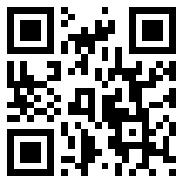

Here you can:

* Inspire children to become life-long learners
* Find a relaxing place to read, exchange ideas and access the Internet
* Improve your technology skills via one-on-one tutorials
* Attend programs on art, poetry, music, sculpture, business, health and others
* Take a class on memoir writing, literature, history or blogging
* Read and discuss a book
* Download and listen to a book
* Get a book via inter-library loan
* Meet with friends and colleagues
* Video conference for personal and business matters
* Stimulate young imaginations to explore the world through books and activities
* Attend online classes

Monday, Wednesday - Friday 10 am – 6 pm

Tuesday 10 am – 8 pm

Saturday 10 am – 4 pm

Sunday Closed

**Norman Williams**

**Public Library**

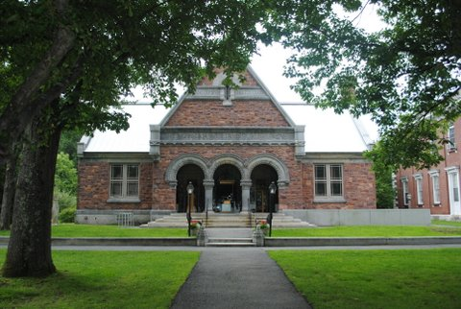

*The Cornerstone of the Community*

in

Woodstock, Vermont

W

Our Story

Woodstock has always been an exceptionally literate community. Our library is a historic building on the Town Green in the heart of the village. It was built in 1883 by Edward Williams as a tribute to his parents, Norman and Mary, to ensure that their love of reading and books continues for generations.

For over 130 years the library has served the community as a place to gather for discussing current issues, enjoying art and music, and introducing children to the magic of literacy.

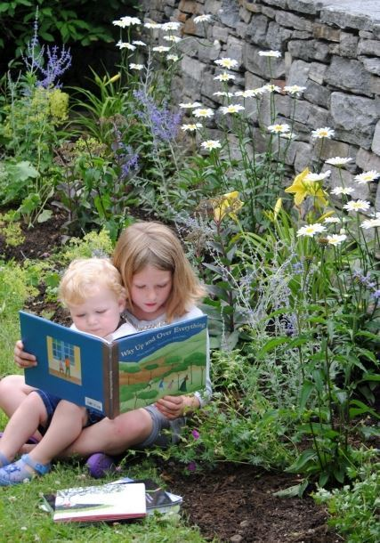

Local residents and visitors can find a relaxing place to read, exchange ideas and access the Internet.

Our Collection

With over 55,000 volumes Norman Williams Library has one of the largest collections in Vermont among libraries serving a comparable patron population. Comprising popular fiction, non-fiction, as well as literature and more for children and young adults, the Library also boasts a wide array of audio books, a growing large print collection and both digital and print reference sources. We also offer patrons access to downloadable audio and e-books. Our Vermont History Room houses books and documents on Woodstock and Vermont history as well as genealogical resources.

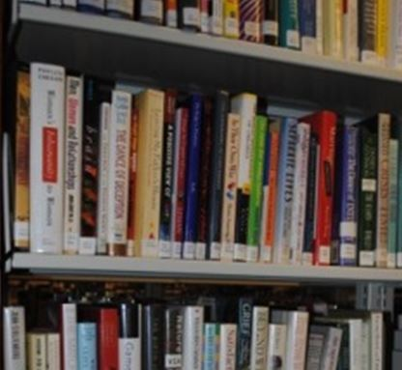

Our Mission

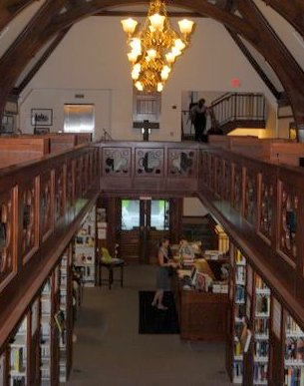

*The Norman Williams Public Library seeks to enrich the intellectual, cultural, and civic life of greater Woodstock by promoting a love of reading and lifelong learning; fostering the free exchange of ideas; providing a welcoming space for people of all ages and backgrounds; and offering resources for building a more just and humane community.*